package connection;
import org.bson.Document;
import com.mongodb.client.FindIterable;
import com.mongodb.client.MongoClient;
import com.mongodb.client.MongoClients;
import com.mongodb.client.MongoCollection;
import com.mongodb.client.MongoDatabase;
import com.mongodb.client.MongoIterable;

public class collection_two {
public static void main(String[] args) {
// Creating a Mongo client
MongoClient mongoClient = MongoClients.create("mongodb://localhost:27017");
MongoDatabase database = mongoClient.getDatabase("myDb");
MongoCollection<Document> collection = database.getCollection("products");
Document priceRangeQuery = new Document("price", new Document("$gte", 700).append("$lte", 900));
FindIterable<Document> products = collection.find(priceRangeQuery);
for (Document product : products) {
System.out.println(product.toJson());
}

}
}
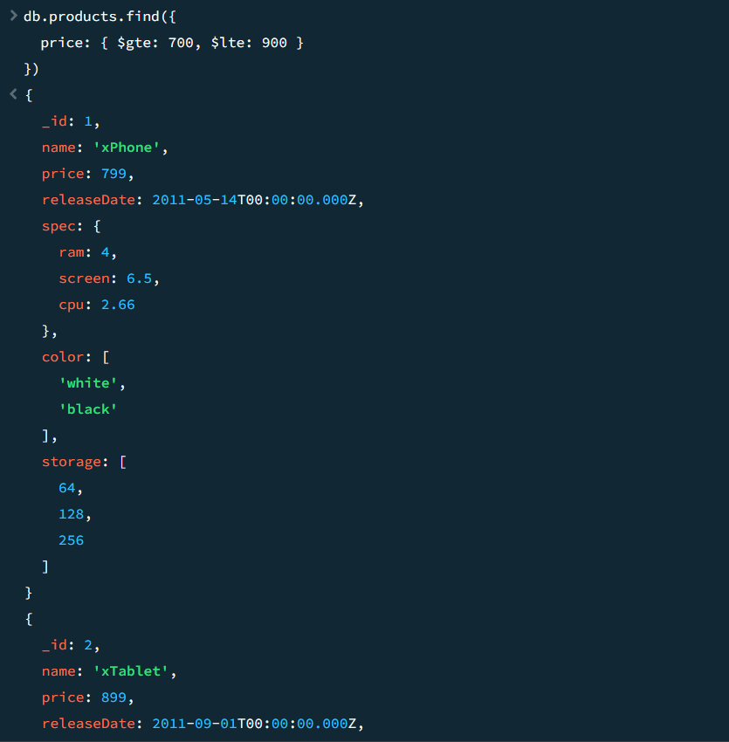
package connection;
import java.util.Arrays;

import org.bson.Document;

import com.mongodb.client.AggregateIterable;
import com.mongodb.client.FindIterable;
import com.mongodb.client.MongoClient;
import com.mongodb.client.MongoClients;
import com.mongodb.client.MongoCollection;
import com.mongodb.client.MongoDatabase;
import com.mongodb.client.MongoIterable;

public class collection_two {
public static void main(String[] args) {
// Creating a Mongo client
MongoClient mongoClient = MongoClients.create("mongodb://localhost:27017");
MongoDatabase database = mongoClient.getDatabase("myDb");
MongoCollection<Document> collection = database.getCollection("products");
AggregateIterable<Document> result = collection.aggregate(Arrays.asList(
new Document("$match", new Document("price", new Document("$ne", null))), // filter documents where price is not null
new Document("$group", new Document("_id", null)
.append("totalPrice", new Document("$sum", "$price"))
.append("count", new Document("$sum", 1)))
));

for (Document doc : result) {
System.out.println("Total Price: " + doc.getInteger("totalPrice"));
System.out.println("Count: " + doc.getInteger("count"));
}

}
}
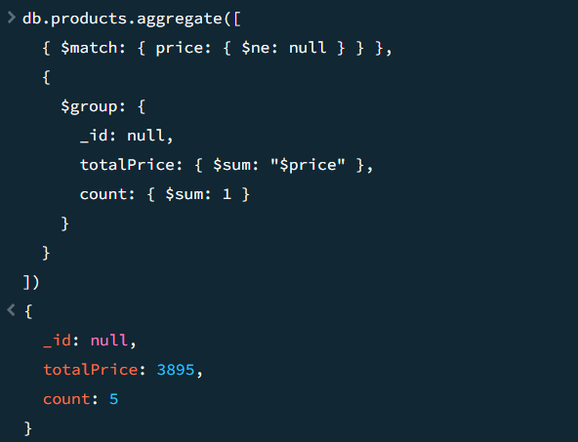
package connection;
import java.util.Arrays;

import org.bson.Document;

import com.mongodb.client.AggregateIterable;
import com.mongodb.client.FindIterable;
import com.mongodb.client.MongoClient;
import com.mongodb.client.MongoClients;
import com.mongodb.client.MongoCollection;
import com.mongodb.client.MongoDatabase;
import com.mongodb.client.MongoIterable;

public class collection_two {
public static void main(String[] args) {
// Creating a Mongo client
MongoClient mongoClient = MongoClients.create("mongodb://localhost:27017");
MongoDatabase database = mongoClient.getDatabase("myDb");
MongoCollection<Document> collection = database.getCollection("sales");
AggregateIterable<Document> result = collection.aggregate(Arrays.asList(
new Document("$sort", new Document("item", 1).append("price", -1)),
new Document("$group", new Document("_id", "$item")
.append("maxPrice", new Document("$first", "$price"))
.append("document", new Document("$first", "$$ROOT"))),
new Document("$replaceRoot", new Document("newRoot", "$document"))
));

for (Document doc : result) {
System.out.println(doc.toJson());
}

}
}
